A free printable discussion guide for
Drone Child: A Novel of War, Family, and Survival
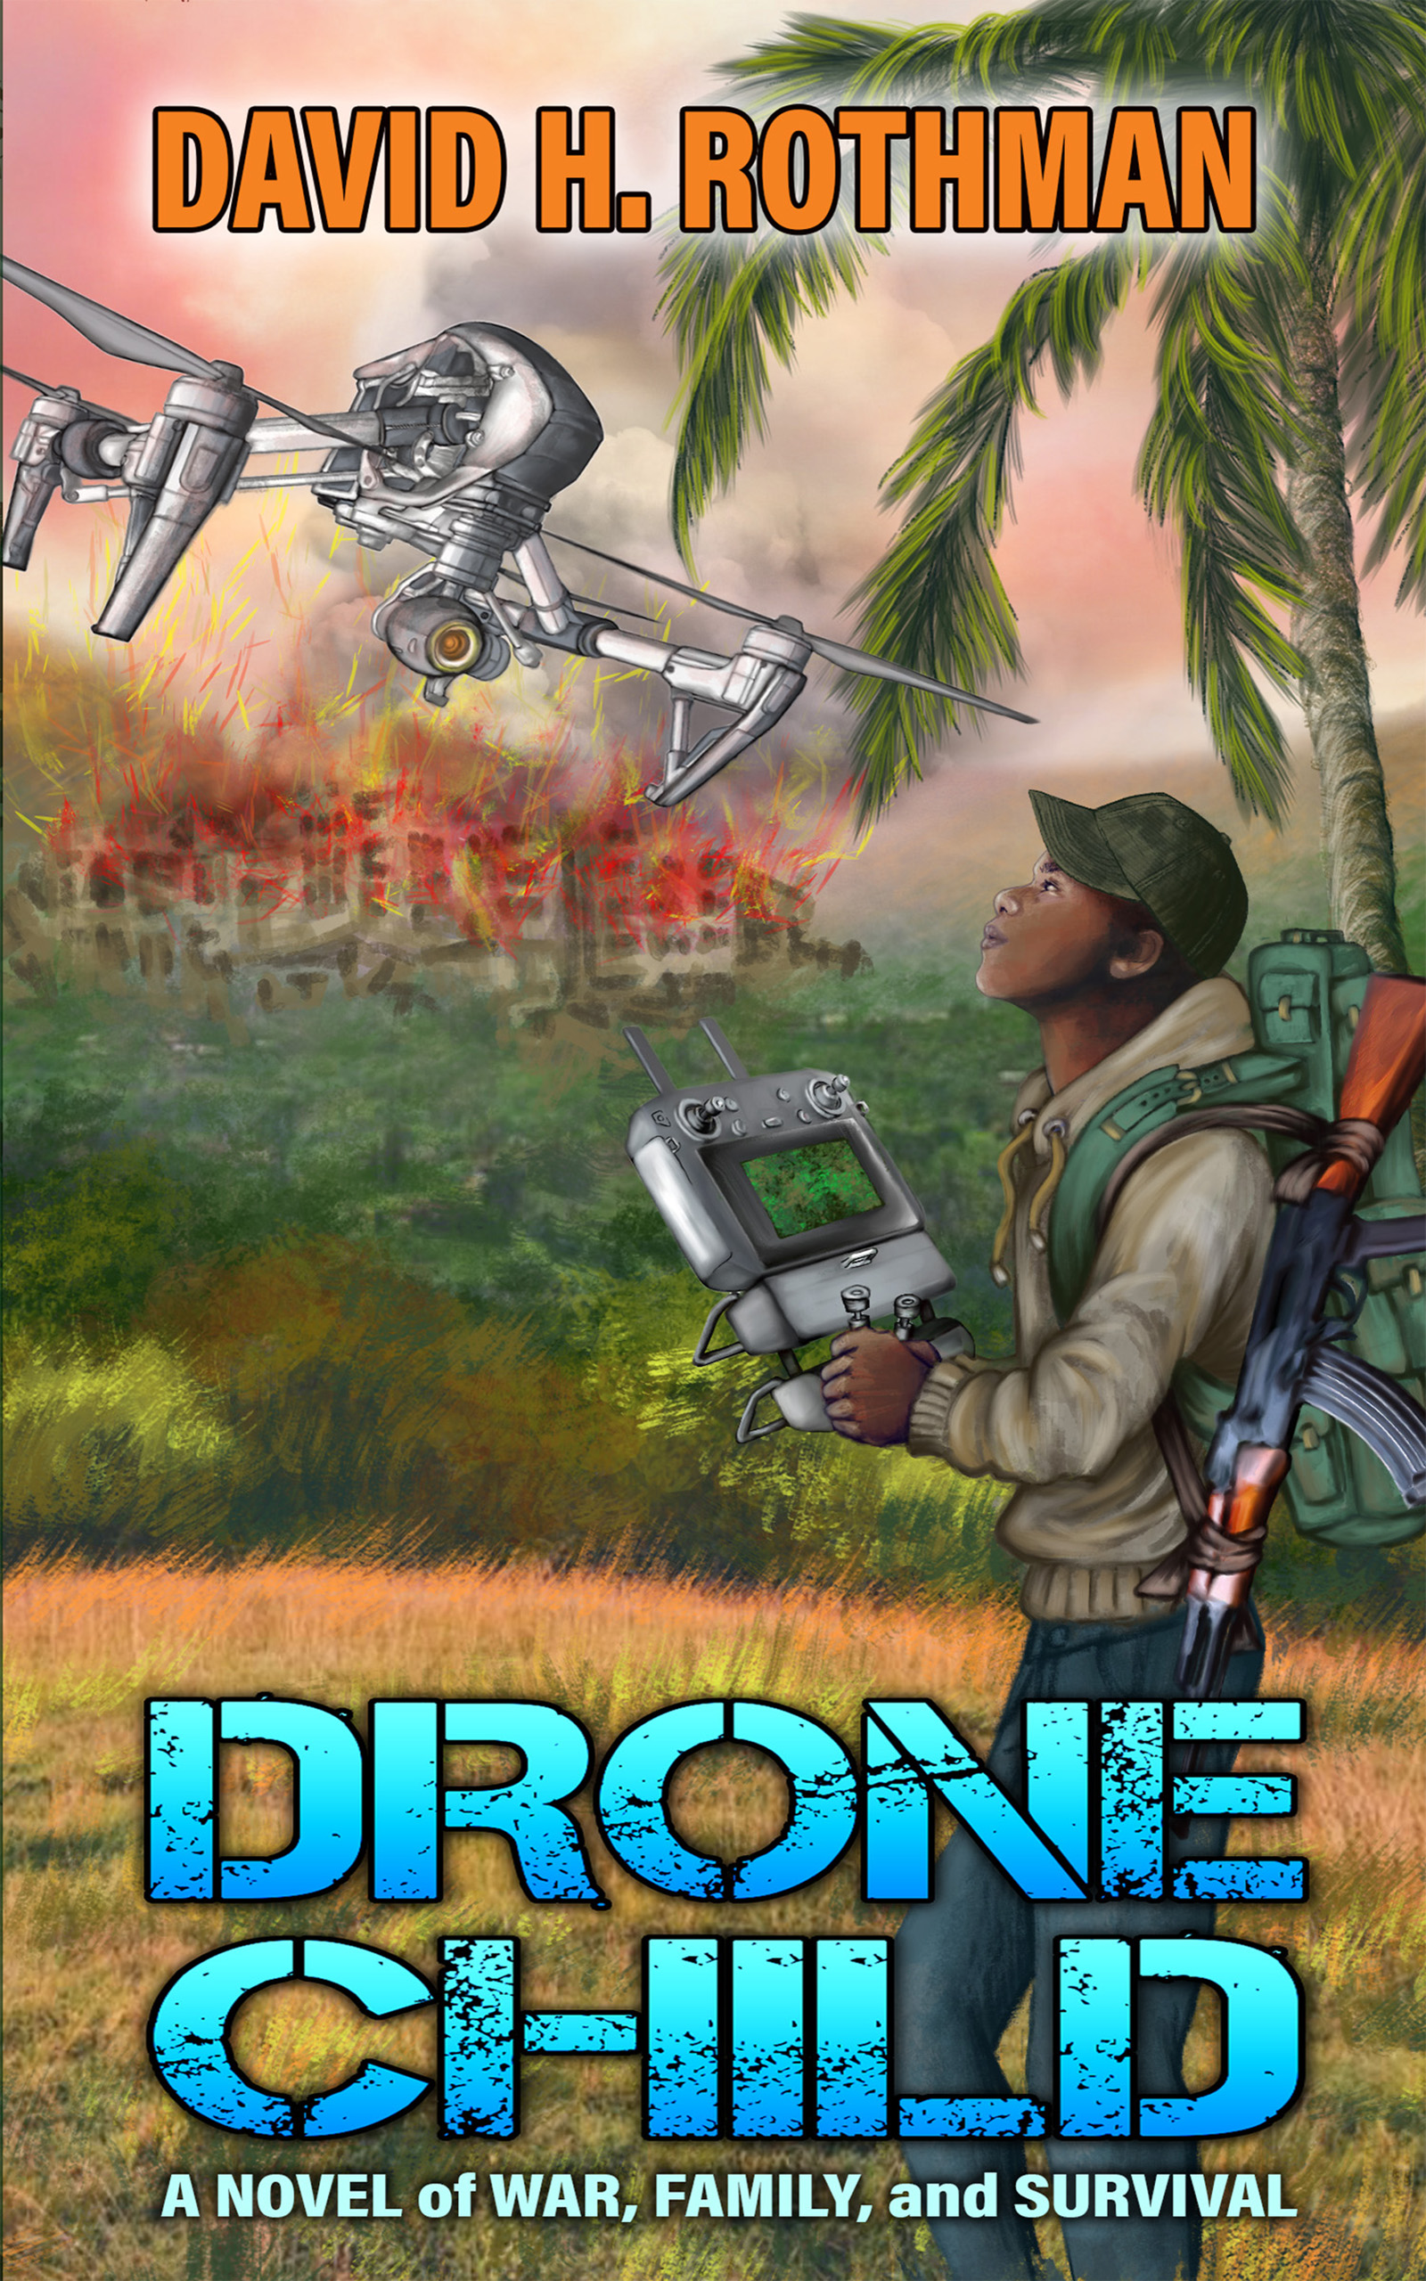
In Drone Child, a genius child soldier struggles to survive and to save his family from machete-wielding terrorists. He later rescues countless other people.
Below are 34 discussion questions about Child for book clubs, schools, and libraries. You need not answer all of them, just those most appropriate for you or your organization. Why not pick out the 10 best questions for your own use?
If you don’t own the novel yet, check out stores or else go to DroneChild.com for helpful buying information.
#1: What are the ways in which Lemba Adula, the brilliant protagonist, "rescues” others besides his family? I’m using the R word both literally and figuratively.
#2: Mpasi, Lemba’s fellow child soldier, ends up eagerly committing atrocities. Why has he succumbed to indoctrination from the Congolese Purification Army, and why has Lemba resisted it? How much do Mpsai’s war crimes stem from the trauma of being forced to kill his own parents and baby brothers? To what extent do other explanations count for both boys, such as upbringing and innate qualities?
#3: Lemba is peaceful by nature but loves technology. How does he reconcile this enthusiasm with the reality that bad people can use drones, computers, and other tech for evil purposes?
#4: The Purifiers give Lemba a choice. He can either become a military drone whiz and help slaughter hundreds of people for these barbarians or see his parents shot or macheted to death. Which option would you choose and why?
#5: Can the case be made that the Purifiers aren’t genuine soldiers but rather gangsters in uniform? Instead of fighting a genuine civil war, might they instead be engaged in a series of criminal actions? To what extent do they really believe in their cause, as opposed to a chance to plunder, rape, and kill?
#6: Lemba’s parents were both orphans. What’s the significance of that, in various respects?
#7: How do his parents pave the way for him and his sister to succeed in life? Why have they taken such constructive interest in their children? Not all parents would to the same extent.
#8: People in Lemba’s village care about education. How much has this community interest also contributed to the success of Lemba and his sister? Why do parents in some places value education while others don’t?
#9: How did Josiane, Lemba’s sister, help him get ahead (and vice versa)?
#10: What do you like and dislike most about Lemba as a person? How do you feel about Josiane?
#11: In what ways could Lemba and Josiane serve as role models for teenagers and other young people in violence-plagued communities in the United States or elsewhere?
#12: How reliable a narrator is Lemba? Are there any places in the book where you distrust him? Is Lemba always credible?
#13: What do you think of Lemba’s decision to remain in the Congo rather than depart for America or another country with many more educational and professional opportunities?
#14: Why does Lemba marry a woman from a wealthy, influential family? Are love and shared values the only reasons? Is there any opportunism here, either financial or otherwise?
#15: Monsieur Favre, a fictitious Swiss philanthropist, is helpful both to Lemba and the Democratic Republic of the Congo. But in the real world in Africa, would a First World philanthropist care as much and have such pure motives? Why or why not?
#16: To what extent might the Democratic Republic of the Congo be a more peaceful and prosperous country today if European colonialists had not murdered and exploited millions of Congolese?
#17: Many of the ancestors of Black Americans came from the places now known as Democratic Republic of the Congo and the Republic of the Congo. Does America owe the current inhabitants any reparations? Should Europeans whose countries colonized the Congo also make amends?
#18: How could trade and foreign aid policies be more helpful both to America and poor countries like the Congo? Please note that the Democratic Republic of the Congo is a major global source of strategic minerals used in electronics and other industries.
#19: Long term, would the DRC really benefit from establishing itself as a source of low-cost goods for First World countries? Or will robotics and artificial intelligence make this model obsolete? How could countries like the DRC adapt?
#20: Ecologically, the Congo is important for its tropical rainforests, which, if destroyed or thinned, would mean more disruptive climate change. How could corrupt politicians there threaten the country’s ecosystem and the world’s?
#21: The Democratic Republic of the Congo is among the world’s poorest countries. How and to what extent is corruption responsible? Are there any lessons here for First World countries like the US?
#22: Virtually all the people hating each other in Drone Child are Africans. But intertribal wars can be as fierce as those between people of different origins. How is Child an allegory of US race relations and politics (among other battlegrounds)? Would the same idea apply to parts of Europe, with tensions over its own ethnic and religious differences?
#23: Just what politicians outside the Congo does Demon Killer, the Purification Army leader, remind you of? In what ways?
#24: What events in Demon Killer’s life most contributed to his monstrous sadism?
#25: How are the gun worshippers in the novel comparable to those in the US? “Gun worshippers” in this case means people who literally worship guns, as opposed to, say, gung-ho collectors or target shooters.
#26: Countless novelists have depicted Africa as a dark continent without also spotlighting such positives as artistic achievement and the idealism of certain political leaders there. Has this fiction set back social and economic progress by reinforcing stereotypes? Did Joseph Conrad, author of the classic novel Heart of Darkness, do more than his share of damage? Should books like his be banned from school or instead be presented in context as reflecting the racism of their times?
#27: Is all the violence in Drone Child necessary, or is it unavoidable because this is a war novel? Would omitting the most disturbing violence from books like Child even be a disservice to society? Might it at least somewhat reduce the possibility that people would fully understanding the damage war does, including the civil variety?
Prepared in consultation with Karen L. Heilman, M.Ed. Vetted by Jean Félix Mwema Ngandu and Junior Boweya.
* * *
No, the above questions do not cover everything. Here are more questions from Junior himself:
#28: Back when Lemba was just a school kid in his village, he repaired TVs and other appliances. How easy do you think it was for Lemba to familiarize himself with electronics?
#29: What could have been the mental tools used by Josiane to deal with the horrors she experienced in Monsieur Zumbu's basement? How might she have coped afterwards with the traumas without showing her inner scars?
#30: Are local people solely liable for the violence and chaos in the Democratic Republic of the Congo, or might some external influences be involved?
#31: What possible strategies could government officials in Africa use to end interethnic conflicts in rural areas such as the ones depicted in Drone Child?
#32: In the globalization era, what can African emigrants do to address situations like those described in the book—how can they help?
#33: After reading Drone Child and learning the story of this African boy, would you like to visit the Congo? If yes, would it be for tourism or something else? What else if that applies?
#34: What impact has the story made on you now that you’ve finished the book?

